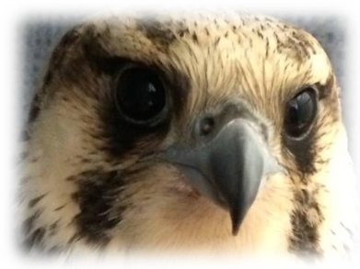
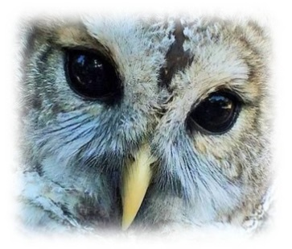
Fellow Mortals Wildlife Hospital
Volunteer Application
Name ____________________________________________________________ Date__________________
Address /City /State /Zip ____________________________________________________________________
Email _____________________________________________________ Phone _______________________
Emergency Contact ____________________________ Phone _________________ Relationship __________
I am interested in volunteering for the following opportunities: (Refer to Volunteer Descriptions)

- Supply Transport
- Animal Transport
- Climb trees and hang nest boxes
- Sewing Projects
- Yard work
- Solicit and pick up Auction items
- Assist with fundraising/outreach
- Assist with mailings

Please attach a resume of applicable experience for the following opportunities:
- Reception
- Plumbing
- Electrical
- Construction

I am available:
€ Monday ______________________________
€ Tuesday ______________________________
€ Wednesday ___________________________

€ Thursday ____________________________
€ Friday _______________________________
€ Saturday _____________________________
€ Sunday ______________________________
I plan to donate ____________ hours per € Week € Month € Year
€ I am available on short notice (24 hours) on these days ___________________________________________
How did you hear about Fellow Mortals Wildlife Hospital? __________________________________________
What do you hope to gain from your volunteer experience? _______________________________________
__________________________________________________________________________________________
€ I am interested in having Fellow Mortals assess my property for use as a release site
* Release sites are generally a minimum of 10 acres in size, not located near busy roads, not used for hunting or trapping, no more than one hour from the hospital and accessible with short or no notice. If checked, a Release Site Application will be provided for completion.

